THE HABER-BOSCH PROCESS Name_______________

Nitrogen is in proteins and DNA and is an element vital for life. Every living organism must metabolise nitrogen to survive.

Nitrogen gas occupies 79% of the air we breathe, but is almost completely inert (unreactive) and cannot be absorbed by plants. In nature, only bacteria can convert nitrogen gas into soluble ionic compounds that can be absorbed and used by other living organisms.

1. What is it about the structure of nitrogen gas that makes it so unreactive?

_____________________________________________________________________
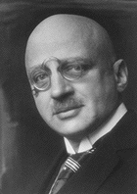
Chemical fertilizers provide an abundant source of nitrogen for plants. Up to the beginning of the 20th Century, nitrogen fertilizers were obtained by mining saltpetre (NaNO₃) from countries such as Chile, but supplies began to run out. In 1908 Fritz Haber discovered a chemical process to make ammonia gas (NH₃) from nitrogen and hydrogen that could be used to make artificial fertilizers. Carl Bosch commercialized the process in 1910. In 1918 Haber won the Nobel Prize in Chemistry for his discovery.

2. The process involves the reaction of hydrogen and nitrogen gas to produce ammonia gas. Write a balanced equation for the reaction:
FRITZ HABER ¹
1868-1934

______________________________________

The clever technology actually involves producing the N₂ and H₂ in the right proportions for the reaction. This is called Synthesis Gas. In Kwinana Western Australia, the company Wesfarmers CSBP is a major manufacturer of NH₃ and uses this process.
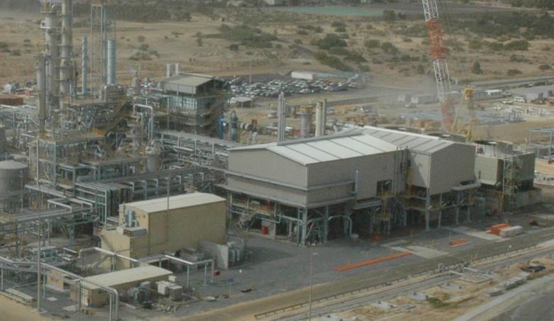

The raw materials used are natural gas, obtained from the North of WA and atmospheric air, which are the source of the hydrogen and nitrogen respectively.
CSBP AMMONIA PLANT

SYNTHESIS GAS PREPARATION

A. NATURAL GAS CLEANING:
The natural gas must firstly be “cleaned” of sulfur contaminants.

3 Why is this step necessary?

____________________________________________________________________
The contaminating sulfur is converted into hydrogen sulfide that is then absorbed in a bed of zinc oxide, resulting in “clean” methane.
CH₃SH_{(g)} + H_{2g} → CH_{4(g)} + H₂S_{(g)}

H₂S_{(g)} + ZnO_{(s)} → ZnS_{(s)} + H₂O(g)

B. REFORMING to produce hydrogen gas:

Primary reforming involves the reaction of steam (H₂O) over a catalyst of NiO to produce carbon monoxide and hydrogen. The carbon monoxide then further reacts with steam to produce carbondioxide and hydrogen. Natural gas is burnt in the primary reformer and temperatures of 760ºC are achieved.

4. Write and balance the two equations for this process:

_______________________________________

_______________________________________

How many moles of hydrogen are produced from one mole of methane? _________

Why is it necessary to burn the natural gas in the primary reformer?

____________________________________________________________________

Secondary reforming occurs with air being added:

CH_{4(g)} + H₂O_{(g)} → CO_{(g)} + 3H_{2(g)}

2 H_{2(g)} + [O_{2(g)} + N_{2(g)}] → 2H₂O_{(g)} + N_{2(g)}

At this stage the ratio of N₂ to H₂ is 1:5

5. The oxygen is burnt in the reaction, raising the temperature to around 950ºC. What advantage is this for the process?

____________________________________________________________________

C. SHIFT REACTIONS:

In the Shift Section, Here two “shifts”, one at a high temperature and one at a lower temperature, convert the CO to CO₂ using excess steam from the reforming section:

SHIFT 1 (400ºC): CO_{(g)} + H₂O_{(g)} → CO_{2(g)} + H_{2(g)}
Here the catalyst is an Fe, Cr and Cu mixture.
SHIFT 2 (200ºC): CO_{(g)} + H₂O_{(g)} → CO_{2(g)} + H_{2(g)}
Here the catalyst is an Zn, Al and Cu mixture.

6. What are catalysts and why are they important?

_____________________________________________________________________

_____________________________________________________________________

D. REMOVAL OF CO₂ and CO:

At CSBP CO₂ is removed by absorbing it into a colourless liquid solvent called activated methyl-di-ethanolamine, CH₃N(C₂H₄OH)₂.

In the process of methanation, the final step is to convert the remaining CO (0.2%) and CO₂ (0.05%) into methane in the methanator:

CO_{2(g)} + 4H_{2(g)} → CH_{4(g)} + 2H₂O_{(g)}
7. Give reasons why this step is very important:

_____________________________________________________________________

_____________________________________________________________________

8. The final mixture, the synthesis gas, has a ratio by volume of 1:3 N₂ to H₂. Why is this the best ratio to achieve?

_____________________________________________________________________

https://www.csbp.com.au/products/AAN/ammonia

AMMONIA SYNTHESIS:

To produce the ammonia, the synthesis gas is compressed to a pressure of 20MPa, heated to 500ºC and passed over catalyst beds of magnetite (iron oxide).

The ΔHº for the reaction is -92.4 kJ/mol.

9. Write the equilibrium constant expression the the reaction:

10. Explain using Le Chatelier’s principle, what is the effect on the equilibrium yield of NH₃ as the temperature is increased?

_____________________________________________________________________

11. What is the effect on the value of K as the reacting temperature is increased?

_____________________________________________________________________

12. Given your answers to questions 10 and 11, why are such apparently high reaction temperatures used?

_____________________________________________________________________

13. Why is the reaction conducted as such a high pressure?

_____________________________________________________________________

_____________________________________________________________________

14. When the synthesis gas is passed over the catalyst beds, only 15% is converted into ammonia. How is this yield increased?

_____________________________________________________________________

15. How is the ammonia gas removed from the mixture of ammonia, nitrogen and hydrogen gases?

_____________________________________________________________________

16. In addition to the production of fertilizers, in what other ways is ammonia used?

_____________________________________________________________________

_____________________________________________________________________

_____________________________________________________________________

_____________________________________________________________________

_____________________________________________________________________

17. List some of the physical and chemical properties of ammonia.

_____________________________________________________________________

_____________________________________________________________________

_____________________________________________________________________

_____________________________________________________________________

_____________________________________________________________________

18. While the ready production of nitrogen fertilizers has sustained many millions of lives on the earth, Haber’s process also cost a few. Find out how the process cost many extra lives during World War 1.

_____________________________________________________________________

_____________________________________________________________________

_____________________________________________________________________

_____________________________________________________________________

_____________________________________________________________________

19. In the process of producing ammonia, list the ways in which CSBP saves energy and resources, which reduce costs and help conserve the environment.

_____________________________________________________________________

_____________________________________________________________________

_____________________________________________________________________

_____________________________________________________________________

1. http://nobelprize.org/nobel_prizes/chemistry/laureates/1918/haber-bio.html

